Introduction Activity - Geography

- Using the word bank see if you can match the key words to spell GEOGRAPHY.

G –
E –
O –
G –
R –
A –
P –
H –
Y –
Word Bank: Aftershock; Economy; Glacier; Globe; Hazard; Oceans; Pollution; Rainfall; Yield:

Stretch and Challenge;

- Draw a picture to symbolise each keyword:

- Define each key word (what does each keyword mean):

Aftershock;

Economy;

Glacier;

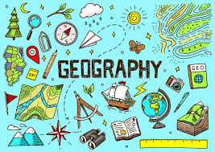
Globe;

Hazard;

Oceans;

Pollution;

Rainfall;
Yield:

